Application

Great Outdoorsevelopment

CASE STUDY

2

Contents

1 Great Outdoors – Company Overview .......................................................................................................... |  |  | 3
1.1 | Introduction ......................................................................................................................................... |  | 3
1.2 | Product Categories ............................................................................................................................... |  | 3
1.3 | Other Highlights ................................................................................................................................... |  | 4
1.4 | Current Strategy& Implementation ...................................................................................................... |  | 4
1.5 | Current IT Environment ........................................................................................................................ |  | 5
2 Returns Reduction Project ............................................................................................................................ |  |  | 6
2.1 | Objective .............................................................................................................................................. |  | 6
2.2 | Functional Requirements - Key Features ............................................................................................... |  | 6
2.2.1 |  | Order Management ...................................................................................................................... | 6
2.2.2 |  | Change Revenue Mix .................................................................................................................... | 6
2.2.3 |  | Returns Management ................................................................................................................... | 7
2.2.4 |  | Retail Store Inventory ................................................................................................................... | 9
2.3 | Non-functional Requirements ..................................................................................................... |  | 9
2.3.1 |  | Performance Requirements .......................................................................................................... | 9
2.3.2 |  | Operations and Reliability ............................................................................................................. | 9
2.3.3 |  | Disaster Recovery Requirements................................................................................................... | 9
2.3.4 |  | Platform Requirements ............................................................................................................... | 10

3

- Great Outdoors – Company Overview

1.1 Introduction

Great Outdoors (GO) is an electronic distributor of outdoor products. GO sources the products from various manufacturers and supplies it to Retailers across various countries.

Due to the lack of intermediaries, GO has been able to price its products very competitively offering significant discounts as compared to its “brick and mortar” rivals. This has helped their revenue grow very rapidly. GO’s gross profit is quite healthy. However, they continue to make investments into the business to drive growth as a result of which their net profit margins are very thin and at times become red as well. So, there is a constant pressure to optimize on costs and enhance profitability so that they can fuel further growth. GO is always looking at opportunities for cost optimization in order to enhance profitability

In terms of market presence, they have:

a strong presence in the Americas have made good inroads in Europe
are relatively nonexistent in the emerging economies

1.2 Product Categories

They primarily deal with 5 product categories:

1. Camping Equipment

o This is the second largest contributor ( ~ 35%) to GO’s top line

o Gross profit % is ~36% – 37% and is much lower than the overall average of 40% - 41% 2. Golf Equipment

o Contributes to ~ 15% of the overall revenue

o Gross profit is around 18% - 20% higher than the overall average 3. Mountaineering Equipment

o Since its launch in 2011, this has been doing well and contributes to around 10% - 12 % of the top line with Gross profit % at the same level as the overall average

4. Outdoor Protection

o This is the most profitable category. Gross profit is around 50% higher than the overall average. This category is a cause for concern esp. as its contribution to the top line has reduced significantly year on year from 4% in 2010 to 0.4% in the 2013 ( till July)

5. Personal Accessories

o This is the largest and the best performing category
- Revenue share is 40+%

- Gross Profit is in the same range as the overall Gross profit of GO

4

1.3 Other Highlights

Since 2010, Great Outdoor’s revenue has been increasing at a rapid rate of > 26% per year on year

Gross Profit is quite healthy at 40+%. In fact till 2012, Gross profit has been increasing even as the annual revenue base has been increasing from ~0.91B USD in 2010 to 1.5 B USD in 2012. This is quite remarkable o One of the major factors contributing to the increase in profits is the reduction in the share of telephone and “sales visit” driven sales which require human intervention and hence a

corresponding cost and an increase in the share of web and email driven orders

  - In 2012, web contributed to 89.6% of all the orders (by value). In 2013, for the first seven months, web contributed to 91.1% of all the orders (by value)

  - In 2013, email contributed to 1.6% of all the orders (by value). In 2013, for the first seven months, web contributed to 1.5% of all the orders (by value)

Both for Top and Bottom line, the quarter on quarter performance is still not predictable. There are huge variations swinging from positive to negative growth. Consistent quarter on quarter performance is essential for the company to go public. This is a major concern for the GO leadership as they have been aiming to go public in order to raise funds for future growth

It seems that “Returns” has been increasing over the years. Returns can be due to multiple reasons:

o Unsatisfactory product

o Defective product

o Incomplete product

o Wrong product ordered

o Wrong product shipped

Off late, some retailers have been reluctant to carry certain products as the “time to sell” post receipt of these products has increased significantly. This negatively impacts the throughput of GO and the Retailer and is a “lose – lose” situation for both. However, this data is currently not captured in the IT systems and hence there is no way to measure and improve this parameter

1.4 Current Strategy& Implementation

Enhance Profitability

o Reduce the share of orders from sales visits from 4.9 % in 2012to 4 % in 2013 o Increase the share of Outdoor protection from 0.7% in 2012 to 1.5% in 2013

o Senior management feels that the decrease in net sales due to “Returns” has increased over the years. While, there is data on the number of items returned across the product categories, data is not readily available on how much this translated into in USD. There is a need to find out the financial impact of “returns” on net sales and minimize the same.

o Reduce the cost of inventory carried by the Retailers due to certain products taking more time to sell at the Retailer’s end

Maintain the Revenue growth at current rates of 25% - 30% year on year o Increase the throughput of products at Retailers

5

The execution of the above strategies requires changes to be made across the board to acquire new business capabilities for which new business initiatives have to be conceptualized and implemented. The changes cut across the following departments/functions:

Supply Chain Sales

Product Design Operations
IT

Finance

1.5 Current IT Environment

GO does not have much legacy and most IT systems are quite new They use TIBCO to drive Enterprise Integration

Go recently implemented a BI solution powered by Cognos to enhance supply chain and sales efficiencies.

6

- Returns Reduction Project

2.1 Objective

To enhance the profitability of GO by helping implement the strategy leveraging the current implementation and enhancing it wherever required

2.2 Functional Requirements - Key Features

2.2.1 Order Management

Reduction of Order received from “Sales visits”. Redirection of these orders either through the web or email

- Incentive for Retailers by offering attractive discounts to change the mix. The discount should not be >20% of the cost savings

Provide monthly/quarterly/annual reports and alerts if the target is o Met

o Not Met o Exceeded

- Reduction in Bonus for sales folks if their contribution to the sales of a retailer goes up from the levels of 2012

Provide monthly/quarterly/annual reports and alerts if the target is

- Met

- Not Met o Exceeded

Also, provide the amount in each case above

2.2.2 Change Revenue Mix

The focus is on increasing the share of Outdoor protection in the overall sales

- Monthly and quarterly promotional discounts for limited period on Outdoor production items. The discounts should not reduce the current Gross profit from these items by more than 20%

Ability to make ad hoc checks on the change in revenue due to these promotional events and provide reports

o On the amount of change ( in USD) o % Change

Month on Month Quarter on Quarter Year on Year
- For every reporting period, color code the data as follows

Green – if the Revenue growth is greater than or equal to 10% Amber if the revenue growth is between 2% to 10%

Red if the revenue growth is 2% or less

7

Provide monthly/quarterly/annual reports and alerts if the discount target is o Met

o Not Met o Exceeded

2.2.3 Returns Management

Reduce Returns by targeting the categories that is in the direct control of GO Operations (where there is no or minimal dependence on the customer):

Incomplete Product

Wrong Product Shipped

- Provide month on month /quarter or quarter /year on year reports on the reduction in Returns for both the reasons (above):

  - # items returned for each reason

  - USD value of these returns

  - % change

Color code the change

  - Green – value of reduction ( in a given period) is >= 10% o Amber – value of reduction is >= 3% but < 10%

o Red – value of reduction is < 3%

Ability to drill down into the reasons for Amber and Red, above o Provide alerts in cases when the wrong product is shipped

Apart from tracking/monitoring product returns, Sr. Management has decided to implement proactive solutions also.

Based on analysis, below are the primary causes for the returns:

- Inadequate product specification details while ordering

- Default shipping address was selected to deliver the products to the customers

Below are the functional requirements to eradicate above mentioned causes of returns:

8
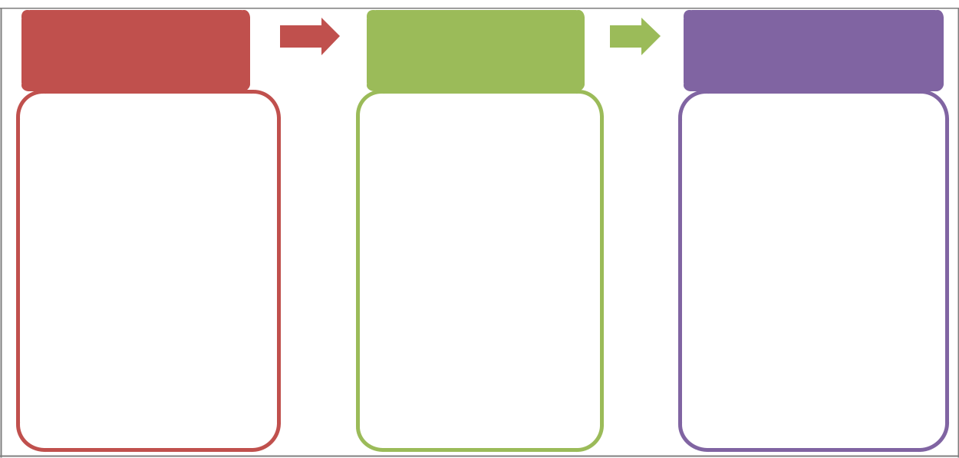

Product Master Customer Addresses List Order Shipping Address

•Tech. Specifications •Change default Shipping •More Shipping Addresses
Address

•Product Images •Frequently Used products &
•Change Product address mapping

•Prod. Specifications change
by customer •History System recomm. •One time use address
on prod. Delivery

•Gift Packing & Shipping
Address

- Build Product Master:

  - Build product master with product details, technical specifications along with product sample images

  - Customer should be able to view all the product details, technical specifications and selected product images, color and product dimensions while ordering.

  - An Option to suggest changes to the product specifications by customer.

- Manage Product Shipping Addresses:

  - Shipping Address selection should be made available for each product in the Customer Order

  - There should be an option to change the default Shipping Address for each product of the Customer Order

  - Ask customer if the selected product needs gift packing or not. If customer says yes then ask explicitly whether change of shipping address is needed or not.

  - Based on customer’s purchase and delivery pattern, system should suggest customer to change the

Shipping Address using customer orders history.

  - An Option to change the product if the customer order is not yet processed.

  - An option to change the shipping address if the customer order is not yet sent for delivery.

- Maintain Customer Addresses List:

  - There should be an option to define more than one shipping addresses at Customer level so that customer can pick up the right shipping address for each product while ordering.

  - Customer should be able to create a new address (if address doesn’t exist that he/she wants) and able to mark it as a onetime use address or add it to his/her addresses list.

  - An option to build frequently purchasing products and its’ associated delivery addresses by the customer. System should be able to suggest this list based on order history.

9

2.2.4 Retail Store Inventory

Reduce the inventory at Retail stores

Provide month on month /quarter or quarter /year on year reports on the time that an item stays on the shelf of the Retailer

o Report the change

Track the time taken for the items to reach the Retailer from the warehouses of GO

- Find out the outliers – the ones that take the least and maximum time
  - At Product category level

  - At item level within the Outlier Product category

  - At item level, irrespective of the Outlier Product category

2.3 Non-functional Requirements

2.3.1 Performance Requirements

All canned reports should be published in < 10 seconds All ad hoc reports should be published in < 5 seconds
Product Master screen should not take more than 2 sec to create a product

Customer Order screen should be able complete submission of customer order within 3 sec including all validations on shipping address.

Customer Address List screen should not take more than 2 sec

2.3.2 Operations and Reliability

Describe the up time requirements, acceptable data loss, and system update (release, reconfiguration) requirements.

Ref. No. | Description | Priority
OR1
OR2

2.3.3 Disaster Recovery Requirements

10

Ref. No. | Description | Priority
DR1
DR2

2.3.4 Platform Requirements

Ref. No. | Description | Priority
PL1
PL2

